# Module 1 : Assignment no .1

* Create 2 resource groups rg-1 and rg-2 .

Step to create resource group:

1. Open the azure portal .
2. There is an option of resource click on it then it will open .
3. Click on create .Then give the name to resource .

For example: rg-1,rg-2.

If want give tags or click review and create .

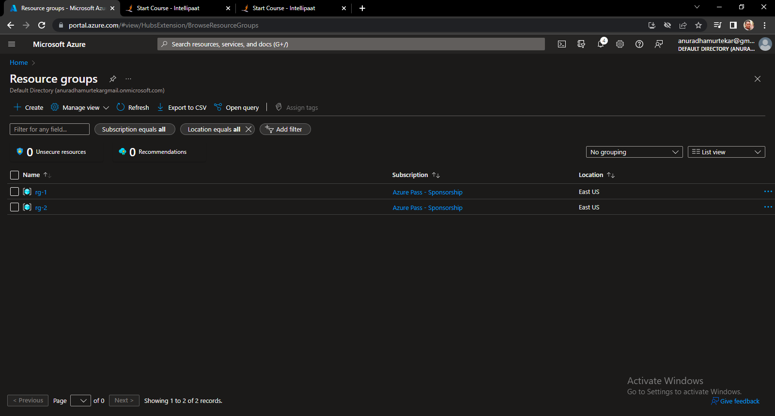

* Add storage Account to rg-1 .

Step to add storage account in resource group 1.

1. Select storage account option dashboard then click on create .
2. Select the resource group name in which we have to create a storage account .Give the storage account a name which should be unique .
3. If want give the tags or if not click on review +create .
4. Wait till validation is complete then click create .

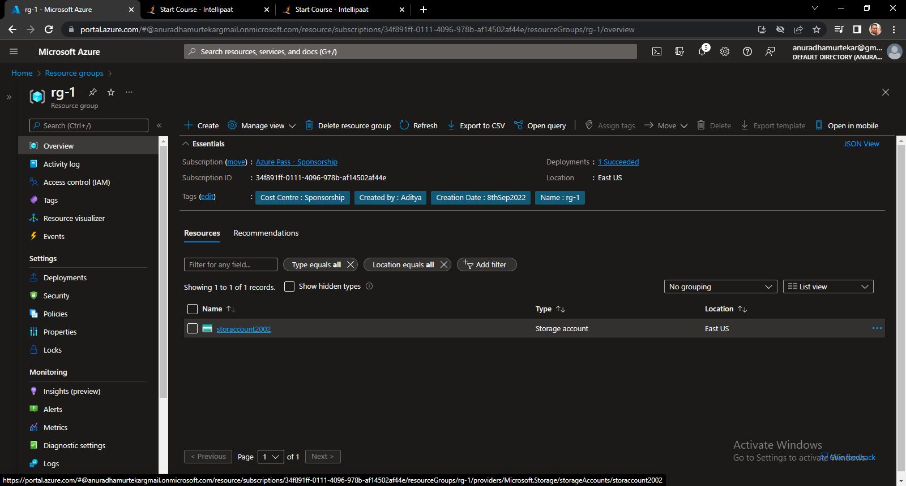

* Move storage account from rg-1 to rg-2

Step to move storage account :

1. Open the storage account from resource rg-1 .
2. In storage account there is option of move .

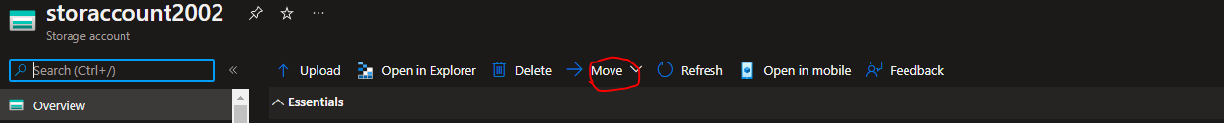

3.select the option Move . In which we can see to option to move storage account in another subscription or another resource group .

4. Use the option another resource group by which we can move another created resource group .

